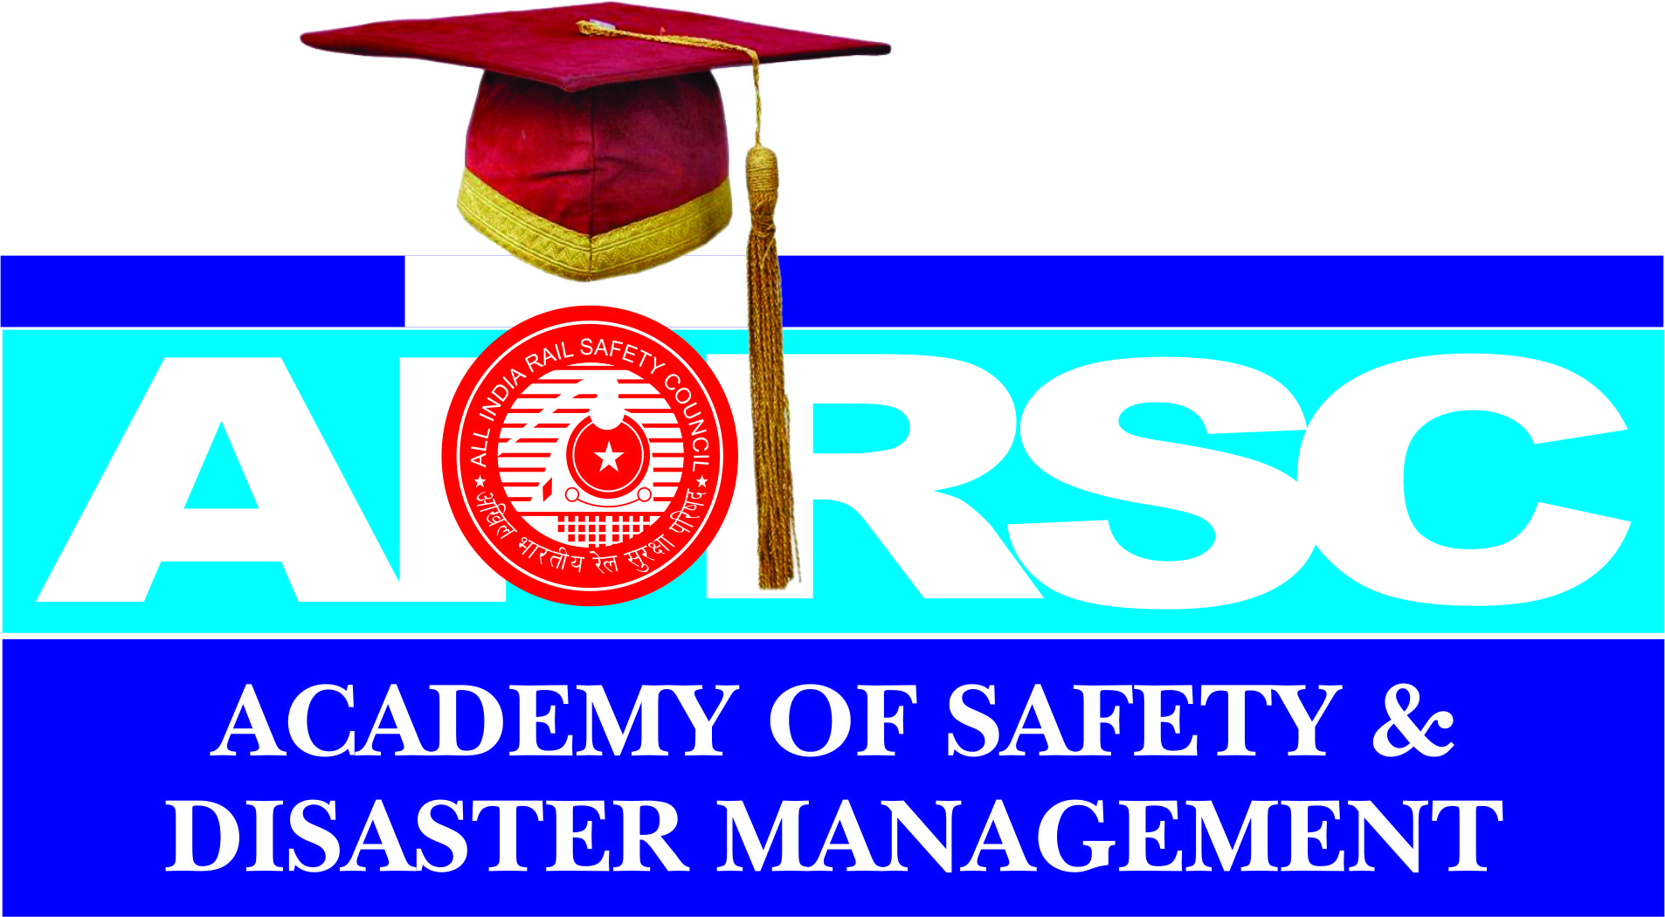

Facilities Provided to the Students by ATRI
100% Placement Guarantee.
At AASDM , We have a very active Training and our placement Service Department to provide appropriate jobs and suitable training to the students Who Will be about to complete their degrees and Diplomas. They will equipped our placement service department handless all aspects at Direct placements for the students at AASDM to ensure the best for the Students.
PLACEMENT

ALL INDIA RAIL SAFETY COUNCIL, we strongly believe in excellent placements for our AIRSC ACSDEMY OF SAFETY AND DESASTER MANAGEMENT students.

We have a placement Service cell handled by our senior committee members at AIRSC who aims at developing the placement services cell to the fullest possible extent to provide suitable jobs and suitable training to the students who will be about to complete their degrees. The placements for the students at various departments. The ALL INDIA RAIL SAFETY COUNCIL has appropriate arrangements in Departments.

