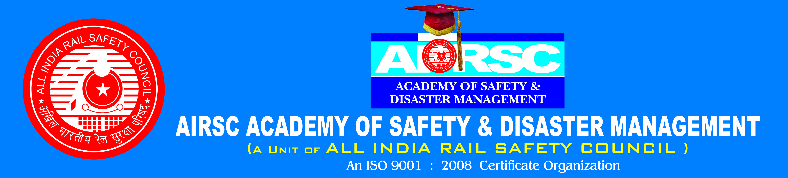
FACILITIES
Facilities Provided to the Students by AASEM
100% Placement Guarantee.
At AASDM , We have a very active Training and our placement Service Department to provide appropriate jobs and suitable training to the students Who Will be about to complete their degrees and Diplomas. They will equipped our placement service department handless all aspects at Direct placements for the students at AASDM to ensure the best for the Students.
PLACEMENT

ALL INDIA RAIL SAFETY COUNCIL, we strongly believe in excellent placements for our AIRSC ACADEMY OF SAFETY AND DESASTER MANAGEMENT students.

We have a placement Service cell handled by our senior committee members at AIRSC who aims at developing the placement services cell to the fullest possible extent to provide suitable jobs and suitable training to the students who will be about to complete their degrees. The placements for the students at various departments. The ALL INDIA RAIL SAFETY COUNCIL has appropriate arrangements in Departments.

FREE LAPTOPS TO STUDENTS

Air conditioned Class Rooms:

The AASDM- institutes is equipped with state – of - the – art lecture halls that are air – conditioned and well it to provide the students with the perfect environment to study in wifi Network.
The entire campus is fitted with a wireless network which enable the students to access the network from virtually anywhere in the campus. If provides them constant access to the network resources as well as mobility.
Compulsory Industry visits.
The course at AASDM is designed such that it incorporates compulsory industry visits in the students to help them gain a first hand experience at the industry and aptly prepare them for their professional experience.

Best at Corporate Facilities

AASDM associate with the Industry and corporate world enables us to present students with the opportunity to have Interactive sessions with well distinguished personalities from the corporate world. The share invaluable experience and guidance with the students that helps them helps them develop in truly world – class professionals.

Best Of Guest Facilities

The AASDM Organizes regular sessions with guest lecturers who are renewed individuals from core fields pertaining to the courses offered AIRSC. The Guest Facilities are well-known personalities in the field at safety education with years at experience at teaching in reputed institutions and Railways and other government sectors safety Departments.

Extra – Curricular

We at AASDM believe that complete all round development of the students is required to make them truly world class professionals. Hence apart from academic activities the AASDM Institute accommodates for extra – Curricular activities and events in the from at various competitions, sports and cultural events and for the students to develop and showcase their all – round talents.

Visiting Faculty from the intellectual at the capital of the Department, some faculty members have a wide international experience that adds variety to the teaching Mechanisms.

Developmental Activities.

Training & Devlopmental Programs - Under the guidance of International &National
Industrial tour, Safety Management Training, Workshops -Student Seminar
General Seminar. Management Development Programmes, National Seminars.

Important Details

Students are expected to be dressed smartly and follow the dress code as per Occasions.
Class Room

Male Students : Uniform :- Blue Shirt , Navy Blue Pant and Black Shoes
Female
Work Shops

Yellow Baniyan Shirt , Blue Pant , Safety Shoes Safety Cap and safety Jacket.

Seminars
Suit Black Shoes And Tie..

Important Details:
Learning in the class through dedicated and experienced faculty is one of the key features at AASDM. Class Room Training helps student get the required skills in a systematic way. Therefore consistency in attendance will be accepted. A minimum 85%

attendanc ( Semester Work) is compulsory for all students, failing which they will be debarred from placements and examinations.

These students who scored 70% and below attendance in first year, will have to repeat the course. No excuses will be entertained.

However, any student who applies for a leave on medical grounds ( Only in case of hospitalization on and any other sickness approved by the AASDM Centre Co-ordinator ) will be sanctioned by the chief Co-ordinator under extra ordinary situation.

Idea about ‘ Detailer List ‘ – No Placement List
1. All Disciplinary Cases.
2. Negative report from the workshops regarding training program.
3. Those students who fail to score required percentage at attendance i.e., 85% (semester wise) .
The list will be prepared by the centre co-ordinator at the end of 3rd semester.
Students will have to submit their attrested copies of degree mark sheets and certificate latest by 1st November 2017. Failing which their admission will be cancelled and fee refund will not be permissible in such cases.

Progress Report
A Progress report ( Attendance , evolution & Performance ) of each student will be sent to parents on a monthly basis by the AASDM center co -ordinator. We insist on regularity in classes, guest lectures, seminars and work - shops, training yards & other curricular activities.

General Rules & Regulations
General Rules
1. It is mandatory for students & their parents to sign a declaration at the time at admission in the format printed on the back of “ Student Personal record form “ in English. This covers conduct / discipline aspect and the general rules.

2. Fees are to be paid on the due dates. No one is eligible for refund on deferred terms of payment under any circumstances. Please see the relevant rules in the hand book given to the students.

3. Attendance in all internal assessment procedures and test is mandatory.

4. No permission shall be grated for leave at absence ( except for acceptable medical reasons) from tests and other internal forms of assessments given it required by the parents / guardian).

5. Students not studying with parents /guardian need to have their place at residence approved by the institute.

6. A student not passing all papers before reaching the final semester shall not be allowed to appear for the papers at the final semester, without passing the papers in arrears.

7. A student who has scored less than 75% attendants in each semester will not be permitted to write semester exams.

8. Those students using their own transport shall be present in their class at least five minutes before the commencement at the classes. Late comers will be permitted only at the discretion of the Teacher. Habitual late comers will be fined.

9. No student shall have the classroom with our permission or till the teacher leaves the room.

10. Students are expected to read the notice board regularly and get themselves in termed of the activities and announcements.

11. For any form or act indiscipline, the AASDM management reserves the right to decide on the quantum of the punishment and/ or corrective action.

12. For any student who has a availed scholarship or fee concession, the amount so availed by the student shall be recovered from the students any rule / regulation or any regulation under the conduct and discipline.

13. Student shall not bring mobile phones to the AASDM Institute.

CONDUCT & DISCIPLINE

RAGGING
AIRSC ACADEMY OF SAFETY AND DESASTER MANAGEMENT has no history of Ragging. It is strictly forbidden in the Institute or any ware. Complaints of ragging will be dealt with severely as per the laws of the land, including dismissal.

Conduct and Behavior.

1. Any behavior or activity in or outside the AASDM campus leading to intended or inadvertent damage of the institution is considered as misconduct and / or indiscipline. Loitering in the verandah, disfiguring or damaging , furniture, writing on the walls are Considered as indiscipline.

2. Respected to the Teachers and others is mandatory. Greeting the fellow students and saluting the teaching staff are considered as good manners.

3. Students shall raise when the teachers enter the classroom.

4. Girls and boys are for bidden to communicate in or outsite the classroom or on the AASDM or while Travelling by the AASDM bus.

5. Absolute Silence must be maintained all over the campus ( and in the ATRI Bus) expect for academic interaction in classrooms or workshops.

6. Movement in and out of the classrooms or workshops should be in an orderly manner without making any noise Girls must be allowed to move out first and then the boys move out.

7. The class teachers shall decide the place of seating forever student.

8. Collective complaining or petitioning shall not be entertained.

9. Student shall wear compulsory uniforms.

10. Discipline takes priority at the AASDM. The AASDM Management reserves the right to determine whether the behavior or action of a student is in violation of conduct / discipline. The AASDM management’s decision shall unilaterally decide on the punishment and / subsequent course at action no representation from the student or parent shall be entertained in this regard.

